**Global Cholera Outbreak Report (1949-2016)**

**Introduction**

Cholera is a severe dehydrating disease caused by *Vibrio cholerae*. It remains a disease of public health importance especially in developing countries which are characterized by inadequate water, sanitation, and hygiene (WaSH) (Chowdhury et al, 2022).

Following an analysis of the WHO raw cholera outbreak data, this report provides a summary of cholera outbreaks in various countries from 1949 – 2016.

**Key findings, trends and patterns**

Globally, 9180678 cases and 897204 deaths have been reported between 1949 and 2016. In general, number of reported cholera cases were higher between 1990 and 2016 compared to 1949 and 1990 (Figure 1). Before 1990, the peaks of the outbreak appear to have occurred in early 1950s and early 1970s. Conversely, after a peak in the 1950s, the number of deaths (Figure 1), and consequently the case fatality rates (Figure 2) declined gradually till it reached a plateau in the 2000s.

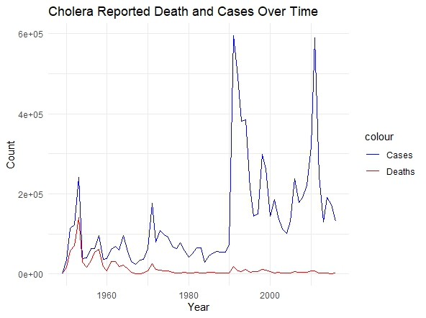

Figure 1: Distribution of reported cholera cases and deaths over time.

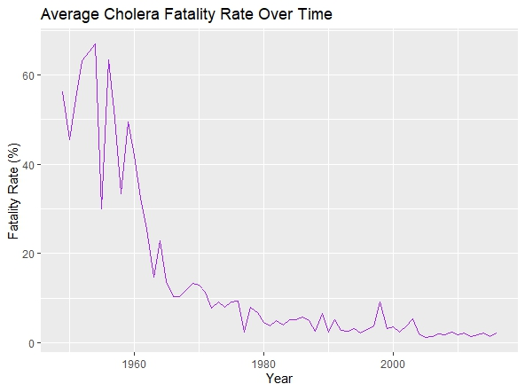Figure 2: Average case fatality rates over time.

Country-wise, India had the highest number of reported cases (1363250) (Figure 3) and deaths (509438) (Figure 4), while Italy had the highest average case fatality rate (53.3%) (Figure 5) over time.

Apart from Haiti and Peru, the top 10 countries with the highest number of cases are Asian (India, Indonesia, Bangladesh, Afghanistan) and African countries (DRC, Mozambique, Somalia, Nigeria) (Figure 3).

Figure 3: Top countries with the highest number of reported cases between 1949 and 1960

Figure 4: Top countries with the highest number of reported deaths between 1949 and 1960

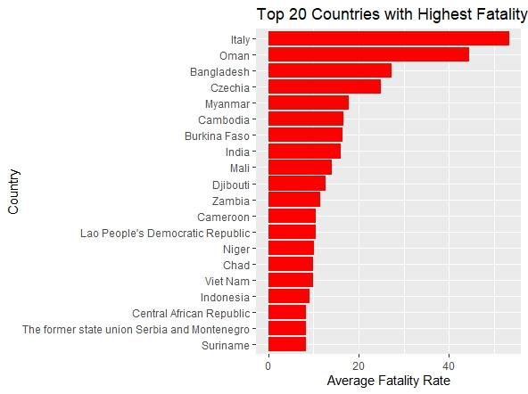

Figure 5: Top countries with the highest case fatality rates between 1949 and 1960

**Discussion**

The decline in the reported cases and death over time may be due to high effectiveness of actions and initiatives geared towards the prevention and control of data. It could also be due to under-reporting of cases and deaths in some countries, especially in resource-limited settings where confirmatory diagnostic tests were not carried out.

Importantly, majority of the countries with reported cases and deaths were Asian and African countries. This is not surprising because *V. cholerae* originated in the Ganges River Delta and remains highly ubiquitous in Africa and Asia and Africa (Morris, 2011). Moreover, these countries are developing countries known for inadequate water, sanitation, and hygiene (Chowdhury et al., 2022).

Considering the severity of the disease and the highly probable under-estimation, efforts towards prevention and control, including vaccination, inexpensive WaSH interventions and increased awareness are still very much required.

**References**

Chowdhury F, Ross AG, Islam MT, McMillan NAJ, Qadri F. Diagnosis, Management, and Future Control of Cholera. *Clin Microbiol Rev*. 2022;35(3):e0021121. doi:10.1128/cmr.00211-21

Morris JG Jr. Cholera--modern pandemic disease of ancient lineage. *Emerg Infect Dis*. 2011;17(11):2099-2104. doi:10.3201/eid1711.111109